Proposal for Project 2

Team: Craig Reid

Date: Oct 3, 2018

Project Overview

This project will build an app that helps users decide which TV series to watch in the era of binge watching and streaming. This is a building block of a larger project to build recommendations with a variety of methodologies including collaborative filtering, SVM, graph database. In order to get the data, step 1 is to create a platform that encourages users to share information. This project represents the first step of step 1. (Step 1 does not include recommendations).

We will encourage participants to enter shows they are watching. As an incentive, we will use a variety of data visualization pages that allow users to see what others in their peer group are watching. Depending on time and complexity, we will add different category views and comparisons to popular movie sites such as iMDB and Rotten Tomatoes. Time permitting, we will enable basic sharing through Twitter, Slack or email.

Data Sets

One important aspect of the project is to capture user generated data. Given the limited time, we will have minimal user input of a few key data points:

* Watched, binged
* Recommend
* Favorite categories

The two primary datasets will be:

* [Open Movie Database (OMDB)](http://www.omdbapi.com/)
* [The Movie Database](https://www.themoviedb.org/documentation/api)

Visualization Inspiration

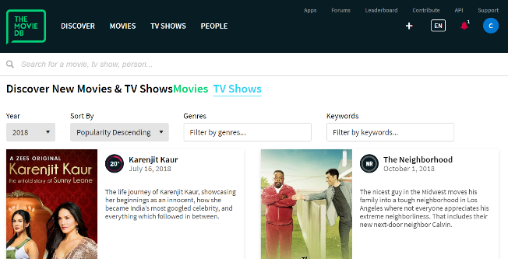

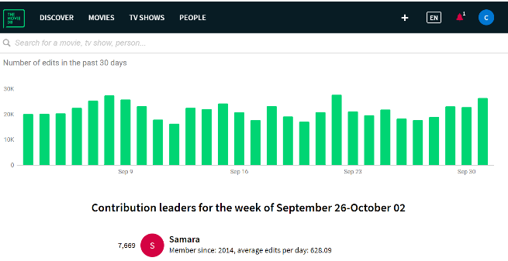

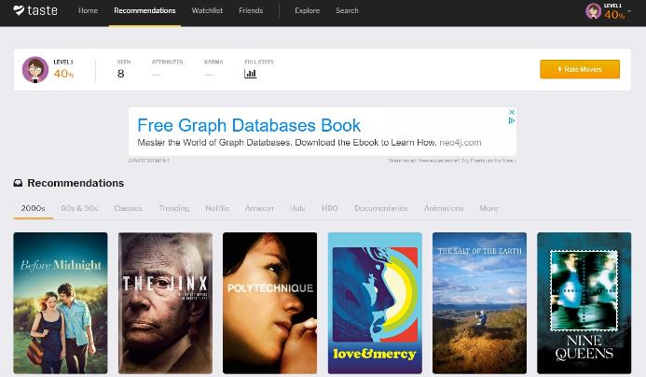

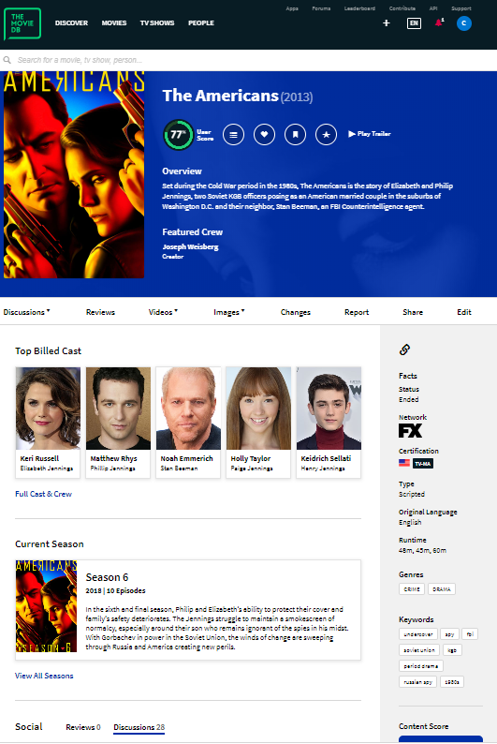

Sketch of Final Design

Git Hub Repository